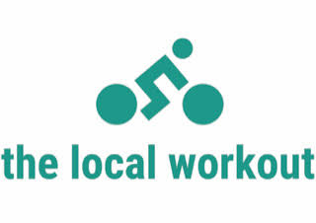 mon. 9 am full body burn 6 pm yoga
tues. 6 am full body burn 9:30 am cycle 4:30 pm yoga 5:30 pm Zumba 6:15 pm Pilates
wed. 9 am strong
thurs. 6 am full body burn 6 pm Zumba
fri. 8 am strong 9 am mat Pilates
sat. 9 am yoga sculpt
class schedule

